TEAM MISSION STATEMENT AND VISION
The HOT Team’s mission is to inspire young people to be leaders in science and technology by engaging them in exciting mentor-based programs that build science, engineering, and technology skills, that inspire innovation, and that foster well-rounded life capabilities including self-confidence, communication, and leadership. The HOT Team vision is similar to the vision of FIRST Founder, Dean Kamen: "To transform our culture by creating a world where science and technology are celebrated and where young people dream of becoming science and technology heroes."

TEAM ORIGIN
The Heroes of Tomorrow (HOT Team) was founded in 1997 from a partnership forged by Ian McEwan, Executive Director of the General Motors Milford Proving Ground, and Dr. James Doyle, Superintendent of Huron Valley Schools, in Milford, Michigan. Participation is open to any student from the Huron Valley Schools District, in addition to students from the International Academy West, located in White Lake, MI, which opened in 2006. There are currently 42 student members on the HOT Team and 19 mentors (some of which are part-time), with membership counts remaining fairly steady over recent years. We are sponsored very generously by Huron Valley Schools and General Motors. In 2009, GM went into bankruptcy. Funding to our team from GM was significantly cut, and the team began additional fundraising events and looked into finding additional sponsors, should the need arise. Fortunately, funding from GM has continued and we have not needed to pursue additional sponsors at this time.

ORGINZATIONAL STRUCTURE
A Board of Directors, with associated by-laws, handles HOT team governance, financial commitments, personnel, sponsors, and ensures continuity of team dynamics. The Board is comprised of representatives of parents, schools, mentors, and sponsors, serving 2-3 year terms, staggered to keep continuity. Commitments for team fundraising, events, or other expenditures of money or student participation must be pre-approved by the Board to ensure that commitments remain true to the team mission and have adequate staffing and funding. The Board selects four officers: the Chairperson runs Board meetings; the Secretary maintains meeting minutes; the Parent Communication Chair keeps parents notified of team events and parent-related responsibilities; the Treasurer makes sure all team funds are properly accounted for. A voluntary student leadership board makes recommendations to the Board on various team issues. The team maintains a bank account for managing fundraising and grant monies, and a school district account for managing student “Pay to Play” funds. We are a nonprofit entity in Michigan and have applied for Federal 501(C)(3) nonprofit status to allow team and potential donors the associated tax advantages. The Board selects a Team Leader to lead day-to-day activities, which are grouped into Engineering and Communications sub-groups, with mentors assigned to each group. Mentor selections are subject to Board approval, within a mentor code of conduct. Student participation criteria are established by the Board, including a student code of conduct and disciplinary procedures.
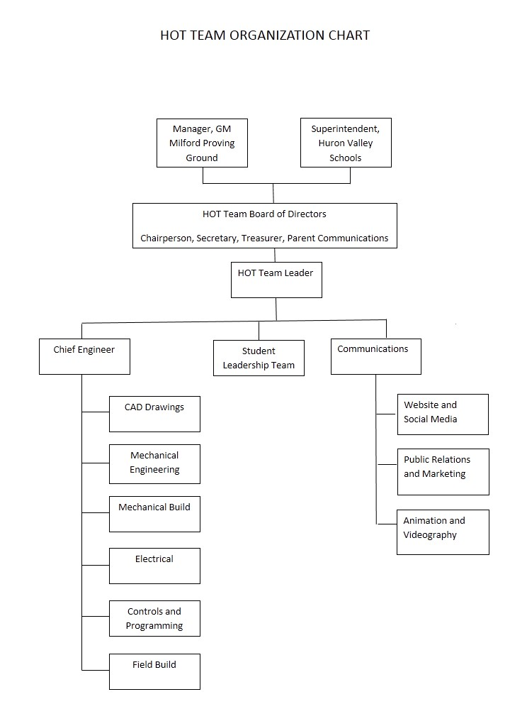

RELATIONSHIPS
Students The HOT Team recruits students from all Huron Valley Schools via an Incoming Freshmen Expo, school announcements, and classroom presentations. The team offers scholarships on an as-needed basis to students who cannot afford team fees to ensure that all students can participate. Tutoring opportunities are offered by team members for students struggling academically. Students learn to use software, machinery, and tools from skilled mentors in order to design, build, and program our robot and communicate our experiences to others. This hands-on approach, and working with a team with a long history of success, inspires HOT students to remain on the team, giving us a student retention rate of about 85%. Many HOT students go on to mentor other FIRST teams and pursue careers in the STEM fields after high school.
Mentors HOT team mentors are HVS employees, current or former GM employees, or HOT team alumni (“Junior Mentors”). The team typically has a 2:1 student to mentor ratio. The HOT team has an enthusiastic group of mentors who participate with the students in community events and volunteer at FIRST district and world events.
Sponsors/Community The HOT Team is sponsored by Huron Valley Schools and General Motors, as well as local companies who donate to our Stay Dry Tri fundraiser. Sponsors for Stay Dry Tri are obtained through personal contact by team members. The HOT Team is well-known in the community for involvement in local events, many of which involve student-led engagement of young people in demonstrations or hands-on activities related to robotics.

DEPLOYMENT OF RESOURCES
The HOT team dedicates many resources to spreading the word of FIRST and inspiring youth by participating in community events and youth development opportunities. Examples of community events include our Stay Dry Tri fundraiser, Milford Memories, Huron River Cleanup, Commerce Road Cleanup, Island Lakes Triathlon, 4th of July Parade, Holiday Parade, YMCA Programs, Detroit Science Center re-opening, and multiple youth presentations. In 1998, we helped pilot FLL and started the first FLL Regional Competition, which we have hosted since then (including all aspects such as logistics, set up, judging, and clean up). HOT team students also volunteer their time and expertise to mentor local FLL teams. This past year, the HOT team worked with local middle schools to start and mentor local FTC teams. Through the years, the HOT team has worked with several rookie and existing FRC teams in need of assistance. Last year we helped the Brighton, MI and Howell, MI teams build their robots, built bumpers and parts for several teams, shared designs and control programs from past years, and helped teams repair robots and debug their controls programs at competitions. To ensure that team members get the most out of the FIRST experience, team members and mentors are assigned to subgroups aligned with their preferred area of expertise and interest, where students are taught how to perform the tasks themselves. FIRST and FRC team opportunities such as on-line tutorials, seminars, off-season competitions, and scholarships are communicated to the team and participation is strongly encouraged.

FUTURE PLANS
Our financial plans for the next three years include maintaining our GM and HVS sponsorship and major fundraising event, the Stay Dry Tri. In addition, we plan to pursue grants, donations, and other fundraising opportunities, some of which have been proposed by our student leadership group. One such opportunity is the FIRST e-watt light bulb fundraiser, which students presented to the Board, and the Board approved, in January, 2014. The student leadership group is currently working out the logistics for this fundraiser. In addition to maintaining our current community service events, the student leadership group has also proposed several community outreach activities. Among these are expansion of FTC teams in our area, robotics workshops in the off-season (both for new team members and community groups such as Boy Scouts working on merit badges), development of CPR/First AID/AED courses for high-school students (with the volunteer assistance of local law enforcement and fire department groups), and an auto repair and safety class sponsored by GM and the HOT Team for high school students. Our animation and videography students are also developing short videos explaining FIRST and how to get involved in our area, which we will pursue being shown at local movie theatres and gas stations. We see these activities as a means to spread the message of FIRST and inspire youth to engage in STEM activites, as well as teaching youth many valuable skills.

RISK ANALYSIS
The HOT Team has developed an effective strategy to avoid substantial threats to team sustainability through the establishment of the HOT team Board of Directors and accompanying by-laws. Our strengths include our large number of experienced mentors, detailed requirements, responsibilities, and code of conduct for mentors and students, community support (particularly for our Stay Dry Tri fundraiser), and relationship with our sponsors, including the use of GM facilities in which to build our robot. Our Board handles all personnel and administrative concerns, leaving mentors free to concentrate on teaching and inspiring the students. One weakness we addressed this year was having a single bank account under control of HVS personnel only. To address this concern, we established a second bank account, with funds being split among the two accounts as described in the ORGINZATIONAL STRUCTURE section above. Potential threats to the HOT team sustainability would primarily come from one of two areas: funding or the availability of the GM machine shop. To mitigate these potential threats, we have explored opportunities for additional sponsors and have identified local machine shops, including our high school resources, where we could potentially build our robot. However, we have elected not to pursue any of these avenues unless/until necessary. In summary, the HOT team has established a system of governance designed to accomplish our mission of inspiring young people to be leaders in science and technology, while providing sufficient safeguards for threats to team sustainability.

